Lesson 1 – What is SAP?



History 2
Terminology 2
Modules 4
Exercise 1 - Log In to SAP for the First Time 5

History

SAP is the world’s leading business and accounting software. It was founded in 1972 by 5 former IBM employees. Key company statistics include:
- Headquarters: Walldorf, Germany
- Employees: 110,000
- Customers: 440,000, including 90% of the Fortune 500
- 2024 Revenue: $40 billion

Terminology
What did SAP originally stand for?
- Systems, Applications and Products in Data Processing
What is SAP?
- Standard Definition: A set of highly integrated software modules that perform common business functions, based on leading multinational business practices
- In Layman’s Terms: A giant accounting software package that models the way organizations do business
What is a Module?
- Functionality that covers a specific business unit within an organization
- Examples include:
  - PM – Plant Maintenance
  - HR - Human Resources (Payroll)
  - CRM – Customer Relationship Management

Modules
SAP’s modules are included in the diagram below:
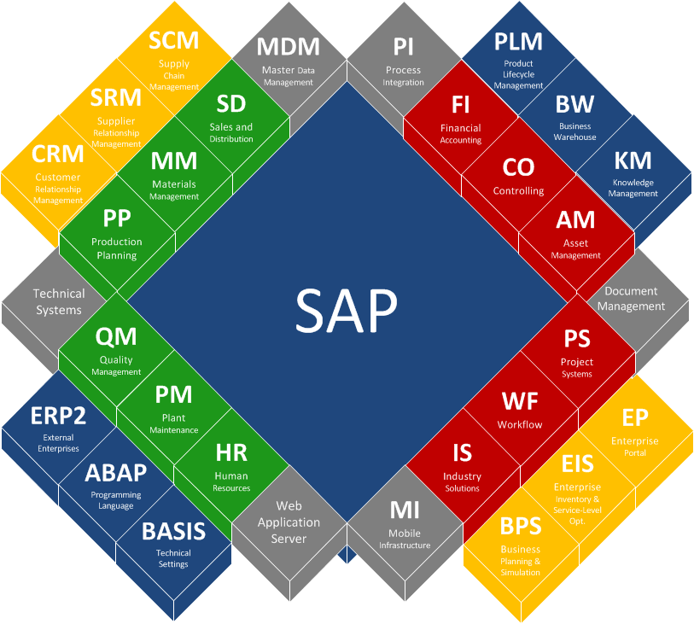

Exercise 1 - Log In to SAP for the First Time
In a browser, go to https://sap.yourprocess.ai:44300/sap/bc/gui/sap/its/webgui/?sap-client=800&sap-language=EN.
The initial login page will be displayed.
Enter your username and password, then hit Enter or click the Log On button.
Stay logged in for subsequent exercises.
